Skill and Job Recommender Application

|  |  |
| --- | --- |
| Team ID | PNT2022TMID52245 |
| Department | Computer Science and Engineering |
| College | Stella Mary’s College Of Engineering |
| Team Leader | Ajai Inith D.L |
| Team Member 1 | Braian Gibson.N |
| Team Member 2 | Goutham M.S |
| Team Member 3 | Sakthivel.K |

✴

**Document an existing experience**

**TIP**

As you add steps to the experience, move each these “Five Es” the left or right depending on the scenario you are documenting.

###### Narrow your focus to a specific scenario or process within an existing product or service. In the **Steps** row, document the step-by-step process someone typically experiences, then add detail to each of the other rows.

**Customer experience journey map**

# DISCOVERY

INITIAL PREPERATIONS

# PREPARATIONS AFTER APPLIED FOR JOBS

FEEDBACKS

# USER STATUS

## Use this framework to better understand customer needs, motivations, and obstacles by illustrating a key scenario or process from start to finish.

**SCENARIO**

**Browsing, booking, attending, and rating a local city tour**

When possible, use this map to

#### Steps

What does the person (or group) typically experience?

User takes a tour to learn about the web application

**Search for jobs**

##### User hunts for jobs based on his skills

**Create and submit resumes**

Complete profile

Feedbacks are collected from users to improve their skills

Feedbacks are collected to improve the application

User gets personalized recommendations based on his status

List of applied companies will be notified

Progress of their quiz assessments will be notified

## document and summarize interviews and observations with real people rather than relying on your hunches or assumptions.

User searches for desired companies

Created in partnership with

#### Interactions

Taking initial assessments of the interview process

User gets notifications after applied for jobs

What interactions do they have at each step along the way?

**People:** Who do they see or talk to?

**Places:** Where are they?

**Things:** What digital touchpoints or physical objects would they use?

Help me to understand about the platform

I can find jobs based on my skills

by uploading

personel details

## 

Search page of the website

Profile page of the website

Search page of the website

Gmail of

Job application page of the website

Google maps of Job seekers

Job assessments page of the website

seekers

Job

Companies

are filtered

based on

user reviews

Company description page of the website

Notification page of the website

Home page of the website

Feedback page of the website

Quiz assessment page of the page

User status page of the website

Home page of the website

**Goals & motivations**

At each step, what is a person’s primary goal or motivation? (“Help me...” or “Help me avoid...”)

I can create my resume in the platform itself

Help me to find jobs in companies where I desire to work

Help me to upload and

create my

Help me to

take initial

I am getting job related notifications

### assessments the company

own profile

provided by

Help me to provide feedbacks

I am able to share my thoughts about companies

I am able to

I am able to get personalized notifications based on my progress

Help me to find my progress in quiz assessments

see the list

of applied

companies

**Positive moments**

Happy when seeing jobs preferred based on user skills

It's fun to understand about the website

Relaxed to see when job acknowledgements arrive at time

Exciting to see personalized notifications based on my progress

Happy to see quizes to improve my skills

It's Useful to see quizes to improve my skills

it's good to see sharing feedbacks about the platform

It's assuring to see other people views on companies

It's exciting to see my skills matching with company recommended skills

Feels good to see features like creating resumes in the platform

What steps does a typical person find enjoyable, productive, fun, motivating, delightful, or exciting?

#### Negative moments

Feels sad when there are not features which users wish to have

Feels sad when there is not a tutorial or guide to know about the platform

Thinks twice to apply jobs in low rated companies

Gets frustated while there is delay in recruiters acknowledgments

Gets disappointed when there are failures in features

What steps does a typical person find frustrating, confusing, angering, costly, or time-consuming?

[**Share template feedback**](https://muralco.typeform.com/to/CiqaHVat?typeform-source=app.mural.co)

#### Areas of opportunity

How might we make each step better? What ideas do we have? What have others suggested?

Provide quizes based on the level of skills users have

Make tutorials more easy,simple and understandable

Show reasons for low rating for companies

Take steps to avoid late reply from the recruiters

Customize resume creation according to user wish

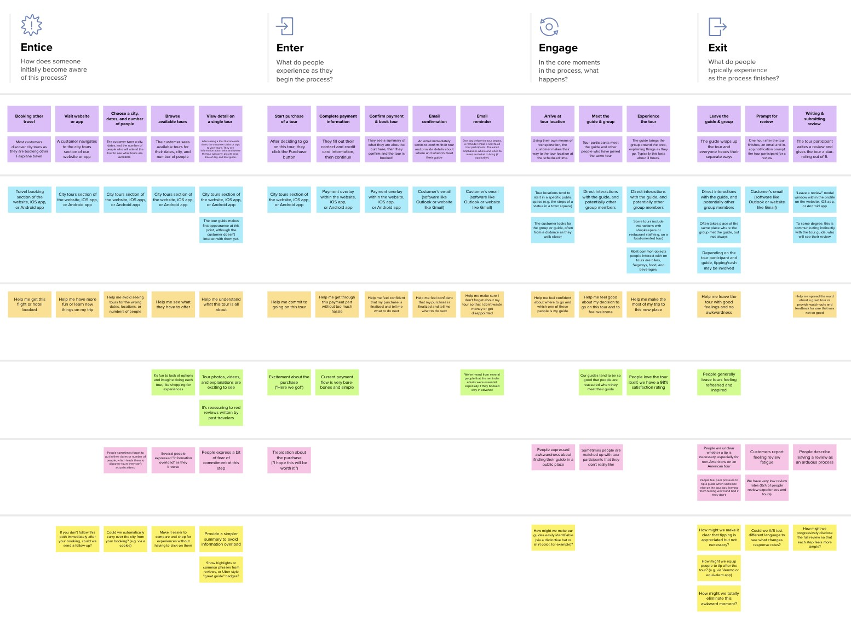

**Template**

**Need some inspiration?**

See a finished version of this template to kickstart your work.

[**Open example**](https://app.mural.co/template/f59f644b-b4b4-47b5-9ed6-3a8c71ceb612/896b31fe-5597-40ef-9b06-3811a1a45ace)